**BLACKWOOD**

**SPECIAL SCHOOLS**

**CHEVIOT RIDE**

**MANUAL**

**For Parents & Guardians**

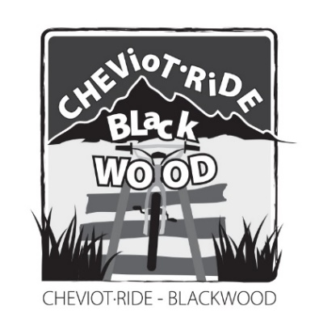

**This camp is a challenge and the students gain enormous confidence and pride in their accomplishments. They MUST be FIT, HEALTHY & GOOD RIDERS. If you have any doubts or concerns about the program please contact the Alpine Ride Co-ordinator at your school.**

**The Cheviot Ride Co-ordinator at your school is:-**

**_________________________________________________________**

**School Phone Number is:-**

**_____________________________________________**

**CHEVIOT RIDE DATES**

**MONDAY 5th DECEMBER 2022**

**to**

**FRIDAY 9th DECEMBER 2022**

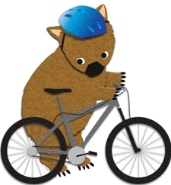

Contents

2022 CHEVIOT RIDE ITINERARY 3

Details 5

THE BLACKWOOD CHEVIOT RIDE 5

RAIL TRAIL BIKE TOUR 5

DET INFORMATION 6

RESPONSIBILITIES 7

LOGISITICS 8

ROAD CROSSING SUPPORT 8

TRANSPORT ARRANGEMENTS 10

ACCOMMODATION 10

WET WEATHER 10

MEALS 10

TOTAL FIRE BAN DAYS 11

CLOTHING 12

BIKES 12

FOR THE RIDE STUDENTS NEED 13

SAFETY 15

EMERGENCY MEDICAL INFORMATION 15

EMERGENCIES 15

COMMUNICATION 15

EMERGENCY NUMBERS 16

RIDING THE GREAT VICTORIAN RAIL TRAIL 16

TRAINING & PREPARATION 16

CHEVIOT TUNNEL 17

PRE-RIDE BRIEFING 18

ALL STAFF SHOULD BE FAMILIAR WITH 19

CAMPER SUPERVISION 19

SAG WAGON 19

MORE INFORMATION 20

# 2022 CHEVIOT RIDE ITINERARY

**MONDAY 5th DECEMBER 2022**

**DRIVE to THORNTON**

* Drive to Thornton
* 4:00pm Staff Meeting - Rubicon Outdoor Education Centre

1 staff member from each school required at the meeting

* 5:20pm Official Cheviot Ride Welcome to Students & Staff
* 6:00pm Dinner

**TUESDAY 6th DECEMBER 2022**

**BIKE RIDE MANSFIELD to MERTON**

* 7am **(NO BREAKFAST)** All Schools depart Rubicon ready to ride
* 8:30am Breakfast – Mansfield Historic Railway Station Car Park Courtesy:- Mansfield Rotary Club
* **8:30am ALL Bus drivers eat first**

**Students & Staff unload buses & prepare to ride**

* **9am BREAKFAST**

**Bus drivers drive buses to Bonnie Doon (except Sag Wagons)**

* 10:00am Depart Mansfield
* 1:30pm Lunch at the Bonnie Doon Community Centre

SCHOOLS HAVE THE OPTION TO FINISH

Bus Drivers drive to Merton – Continuing Schools ONLY

* 2:30pm Depart Bonnie Doon Community Centre
* 4:30pm Arrive Merton
* 5:30am Staff meeting at Rubicon Outdoor Education Centre
* 6:00pm Dinner

**WEDNESDAY 7th DECEMBER 2022**

**BIKE RIDE MERTON to ALEXANDRA**

* 7:30am Breakfast
* 8:30am Depart Rubicon Outdoor Education Centre
* 9:15am Arrive Merton (Toilets on the way into Molesworth station)
* 9:45am Depart Merton on Bikes
* 12:00pm Lunch at Yarck Recreation Reserve
* 1:00pm Finish lunch and begin ride to Alexandra
* 3:00pm Arrive in Alexandra
* 2:30pm Afternoon to explore the Area
* 5:30pm Staff meeting at Rubicon Outdoor Education Centre
* 6:00pm Dinner

**THURSDAY 8th DECEMBER 2022**

**BIKE RIDE MOLESWORTH to YEA (Cheviot Tunnel)**

* 8:00am Breakfast
* 9:00am Depart Rubicon Outdoor Education Centre
* 9:30am Arrive at Molesworth Rail Park
* 10:00am Depart Molesworth on Bikes
* **11:30am Cheviot Tunnel Fun**
* 12:30pm Finish Bike Ride at the Tunnel & begin ride to Yea
* 1:30pm Arrive in Yea

Afternoon to explore the Area

* 4:30pm Return Rubicon Outdoor Education Centre
* 5:30pm Medal Presentation
* 6:00pm Dinner

**FRIDAY 9th DECEMBER 2022**

**RETURN TO SCHOOL**

|  |  |
| --- | --- |
| **CHEVIOT RIDE** | |
| **DAY** | **DISTANCE** |
| **Tuesday** | **36km** |
| **Wednesday** | **38km** |
| **Thursday** | **18km** |
| **TOTAL** | **92km** |

* Schools depart at their Leisure
* ENJOY YOUR WEEKEND

**Details**

* **Maximum 42 students, due to the availability of Beds at Rubicon Outdoor School**
* **Maximum 7 Schools – based on average 6 students per School**
* **Priority given to Schools who have supported our Cheviot Ride in the past**
* **Cost - $200 per student – includes:-**
* **Accommodation**
* **Food**
* **Cap & Medal**
* **Admin Fees**

# THE BLACKWOOD CHEVIOT RIDE

# RAIL TRAIL BIKE TOUR

The Blackwood Cheviot Ride invites students & staff from a variety of Victorian Special Schools to unite together and enjoy a cycling experience along Australia’s longest continuous Rail Trail:-

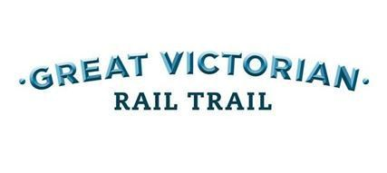

[**http://www.greatvictorianrailtrail.com.au/**](http://www.greatvictorianrailtrail.com.au/)

The Blackwood Cheviot Ride Program is not designed as an easy ride and requires all participants to:-

* Have a good level of fitness
* Good bike riding skill
* Good understanding of how to use gears

The trail follows an undulating route along a smooth gravel surface with a variety of gradients highlighting Victoria’s High Country.

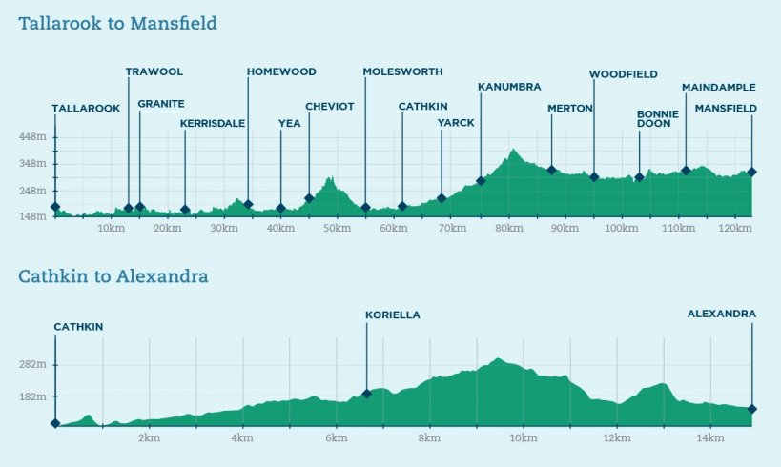

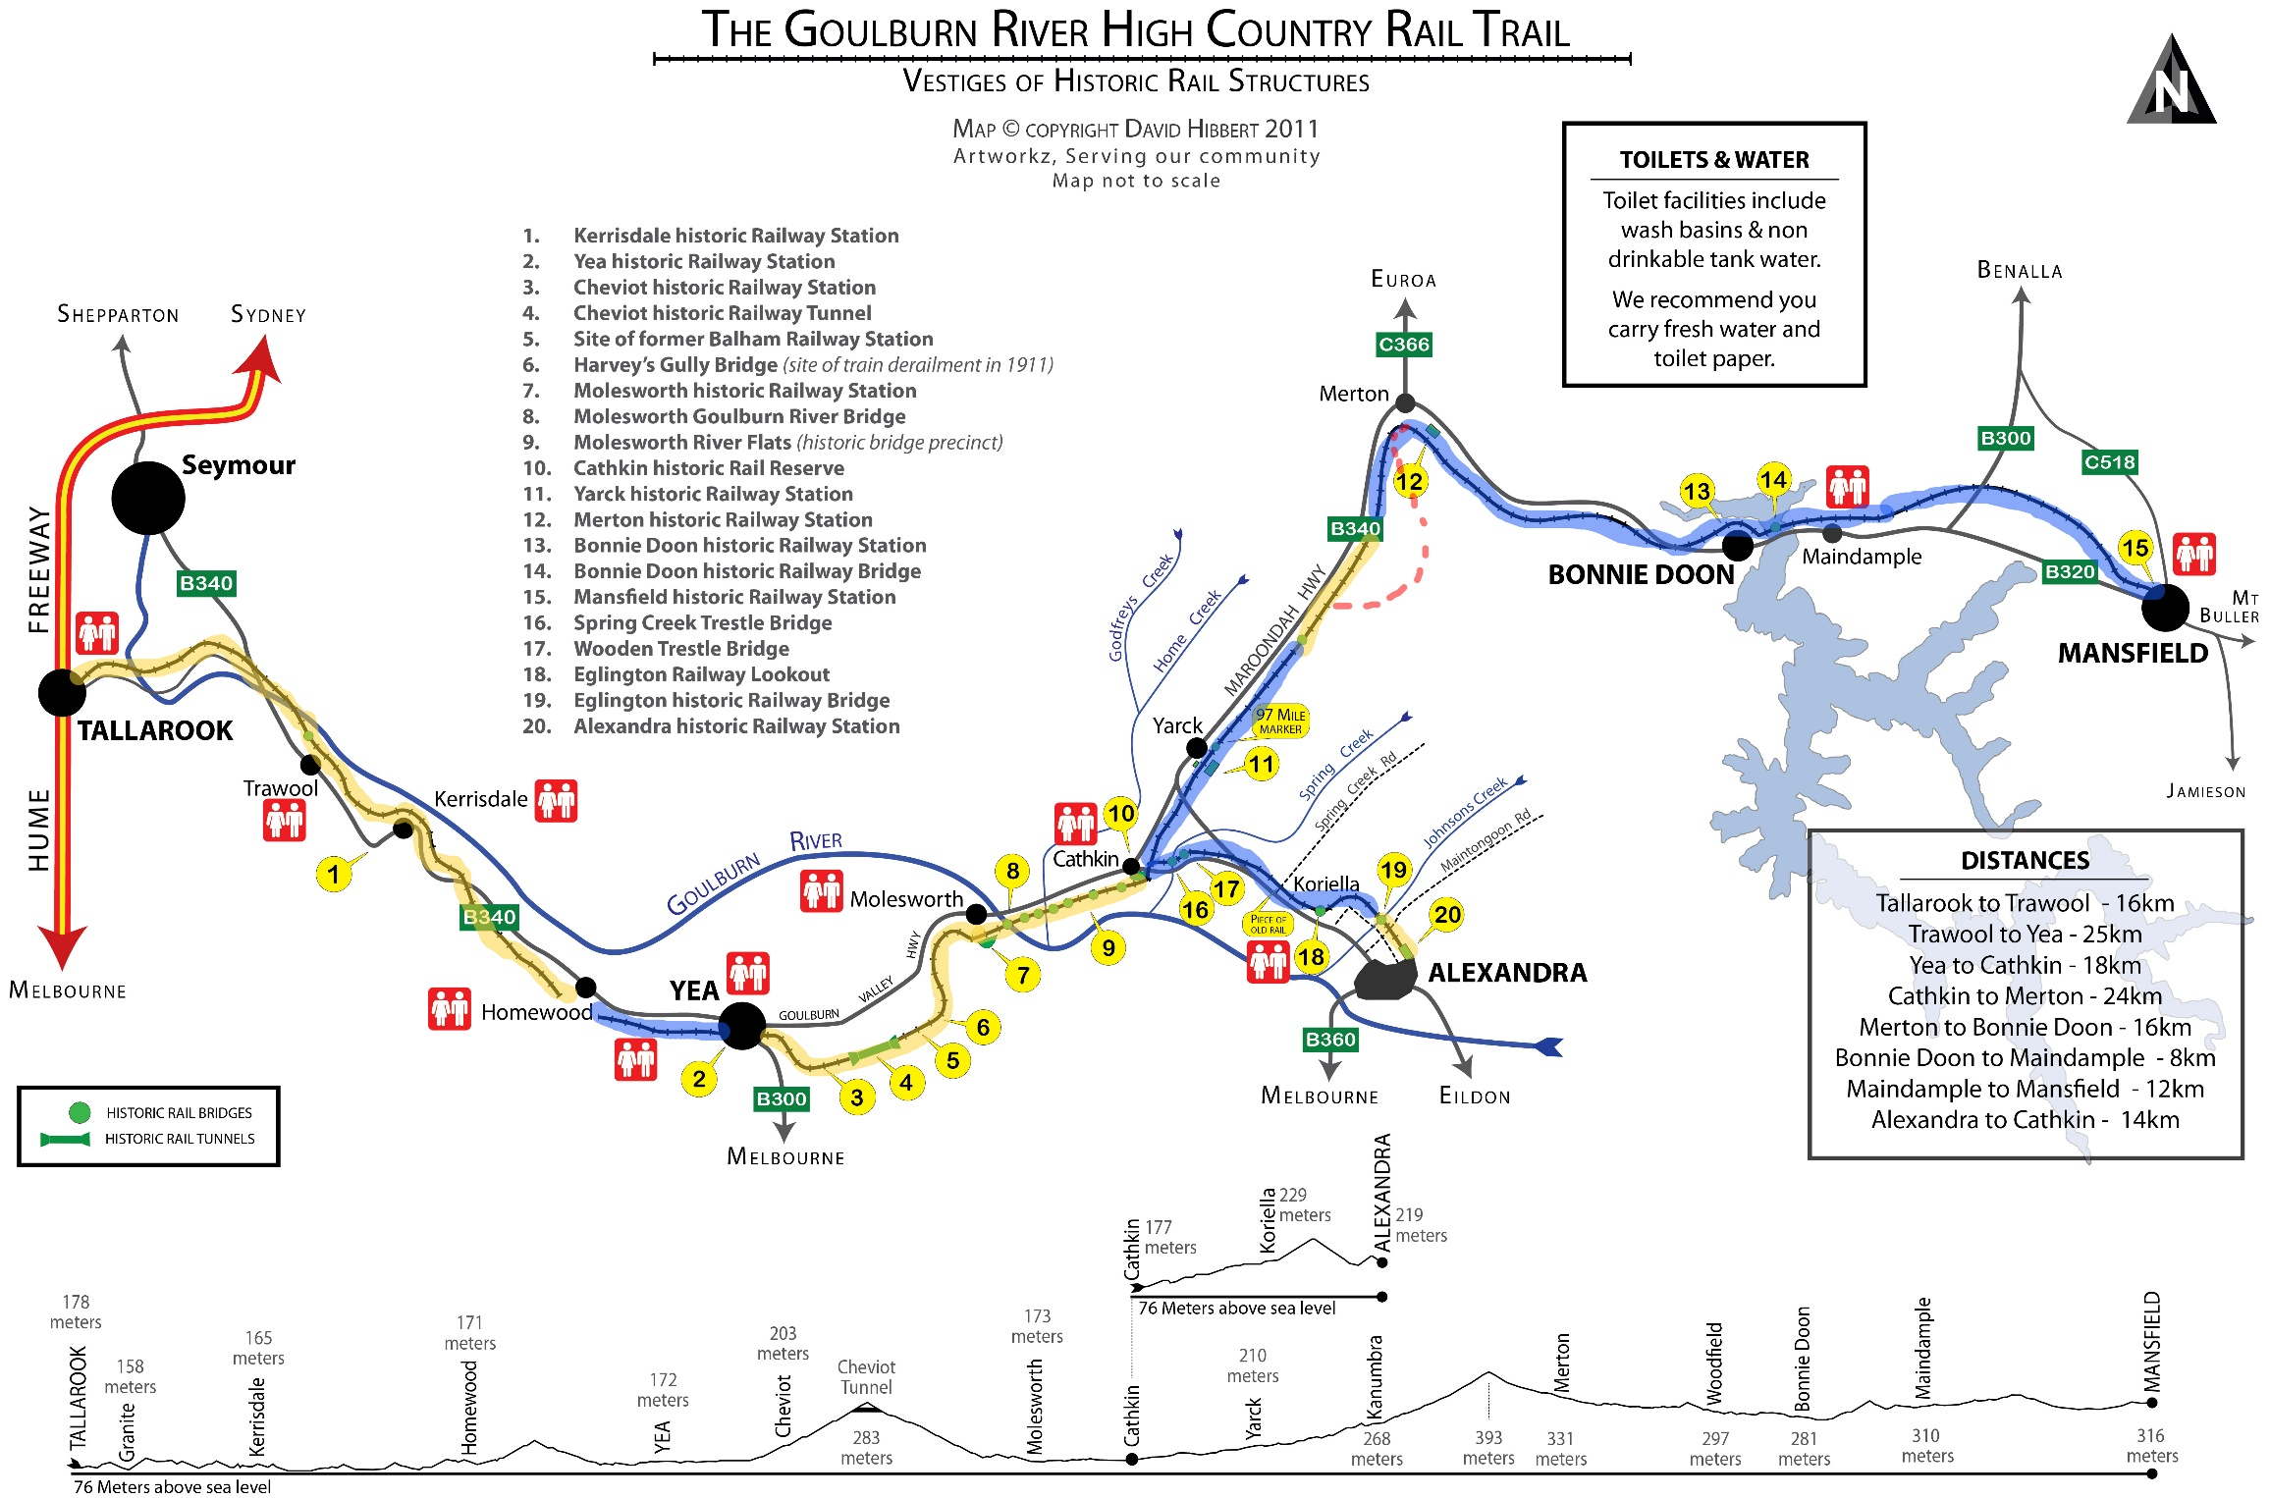

# ACCOMMODATION

* For the entire duration of the Cheviot Ride we will be based at Rubicon Outdoor Education Centre:-

|  |  |  |
| --- | --- | --- |
| **ACCOMMODATION** | **ADDRESS** | **PHONE No.** |
| Rubicon Outdoor Education Centre | 264 Rubicon Rd, Rubicon, 3712 | 5773-2285 |

# WET WEATHER

* Each rider *MUST* have appropriate wet weather gear suitable for use on a ride.
* As *NO* alternative program will be possible, the main ride will take place irrespective of wet weather conditions.
* *NO ALTERNATIVE PROGRAM WILL BE PROVIDED.*

# MEALS

* **ALL SCHOOLS ARE FULLY RESPONSIBLE FOR THE PURCHASE & SUPPLY OF THE FOLLOWING MEALS:-**
* **Lunch – Monday 5th December 2022**
* **Lunch – Friday 9th December 2022**

**All other meals throughout the duration of the Cheviot Ride will be provided by Rubicon Outdoor Education Centre**

# TOTAL FIRE BAN DAYS

* j0232816As the Cheviot Ride will be held in Summer there is a chance that we may encounter Total Fire Ban Days during the ride.

**ALTERNATIVE DAILY PROGRAMS MAY INCLUDE:-**

* Monday:- Continue travelling to Rubicon as planned
* Tuesday:- *Option 1* Individual Schools choose not to ride

and organise their own Free Day

*Option 2* 6:00am Breakfast

6:45am Depart Rubicon for Mansfield

8:00am Ride from Mansfield to Bonnie Doon

**NO-ONE RIDES BEYOND 12:00pm**

1:00pm Lunch at your leisure

*FREE DAY FOR ALL SCHOOLS*

* Wednesday:- *Option 1* Individual Schools choose not to ride and

organise their own Free Day

*Option 2* 6:00am Breakfast / Bus Shuttle to Merton

6:45am Depart Rubicon for Yarck

7:30am Ride Merton to Yarck

**NO-ONE RIDES BEYOND 12:00pm**

***NO OPTION of RIDING BACK***

1:00pm Lunch at your leisure *FREE DAY FOR ALL SCHOOLS*

* Thursday:- *Option 1* Individual Schools choose not to ride and

organise their own Free Day

*Option 2* 6:00am Breakfast / Bus Shuttle to Molesworth

6:45am Depart Rubicon for Molesworth

7:30am Ride Molesworth to Yea

**NO-ONE RIDES BEYOND 12:00pm**

***NO OPTION of RIDING BACK***

1:00pm Lunch at your leisure *FREE DAY FOR ALL SCHOOLS*

* Friday:- Continue travelling home as planned
* *If there is a serious Fire Threat during the week of the Cheviot Ride an appropriate action plan for the safety and well being of all participating students and staff will be put into place by Blackwood Staff under the direction and full co-ordination of Rubicon Staff & local Emergency Services:-*
  + - **The Victorian Police;**
    - **The Country Fire Authority;**
    - **State Emergency Services; and**
    - **The Australian Defence Forces.**
* **In the unlikely event of a serious Fire Threat ALL PARTICIPATING SCHOOLS MUST follow the direction of Blackwood Staff who will be following Emergency Service Directives.**

#### LOCAL RADIO BUSHFIRE UPDATE INFORMATION

|  |  |
| --- | --- |
| **TOWN** | **RADIO STATION** |
| Yea | 774 ABC |
| Mansfield | 3GVR 103.7FM |

# CLOTHING

* Brightly coloured bike tops or T-shirts should be worn on the ride, preferably with a visibility vest.
* Bike shorts reduce chaffing and saddle soreness. Other shorts with fairly long legs are preferable to footy shorts which may rub the top of the thigh.
* Track suit pants are also suitable.
* *Jeans* ***SHOULD NOT*** *be worn as they restrict movement and increase muscle strain.*

# BIKES

* Most schools are now providing bikes.
  + - However if your school allows the use of your child’s own bike, please ensure that it is thoroughly checked (preferably by a bike shop) **before** being brought to the Cheviot Ride.
* **If Schools allow students to bring their own bikes – the teachers from that school will have full responsibility of maintenance & suitability of those bikes for the duration of the Cheviot Ride.**
* Whilst some minor repairs may be carried out – if faults develop during the ride, *it is the responsibility of the parents and each school to ensure that the bikes are mechanically reliable and roadworthy.*
* Mountain bikes are the preferred bike for this event.
* *ALL BIKES MUST HAVE 2 BRAKES.*
* It is essential that at least two (2) water bottles are fitted to the bike.
* Lack of water leads to loss of energy and dehydration.
* Water will be available for refills along the route.

# FOR THE RIDE STUDENTS NEED

* A road worthy bicycle with wide tyres and plenty of tread;
* An approved bicycle helmet (check clasp);
* Water bottle (preferably 2);
* Appropriate bright clothing; and
* Front & rear lights mounted on each bike

STUDENTS NEED TO BRING

|  |  |  |  |  |
| --- | --- | --- | --- | --- |
| **Please remember to clearly name every item with your Son/Daughter’s:-**  **NAME and**  **SCHOOL NAME**  **Thank you** | Sleeping   Bag | Pillow Case | Blanket | Pillow  Pillow Case  Blanket |
| Shorts | 2 X Shorts  (Suitable for riding   bikes long distances) | Pants - Track Suit | Tracksuit   Pants  (Suitable for riding) |
|  | 3 X   T-shirts  (Suitable for riding) | T-shirt - Long Sleeve | 2 X Shirts  (For night time) |
| Pants | 2 X Warm   Pants   (**NO JEANS**) | Jumper | 2 X   Jumpers |
| PJ'sPJ's - Onesie | Onesie or   Pyjamas (Monday is Onesie Night) | Sneakers | 2 X Shoes |
| Socks & Jocks  Bra | 5 X Pair of   Socks &  5 X Underwear | Wet Weather Gear | Wet Weather Gear  (Suitable for riding) |
| SoapToiletries  Toiletries - Hair Brush  Dilly Bag | Toiletries  🗸 Soap & Face Washer  🗸 Toothpaste & Brush  🗸 Deodorant & Brush | Towel | Towel |
| KFS | Dilly Bag  🗸 Plate, Bowl & Cup  🗸 Knife, Fork & Spoon in a draw string bag | SunscreenSunglasses | Sunscreen  Sunglasses |
| Sun Hat  Beanie | Sun Hat  Beanie | Insect RepellantTorch | Torch  Insect   Repellent |
| Water Bottle  Bike Helmet  ***NIGHTS MAY BE VERY COLD AS WE WILL BE IN THE HIGH COUNTRY REGION*** | Water Bottle  Bike Helmet May be supplied by your   School | Asthma PumpMedication | Personal Medication  (Clearly labelled with your family name) |

# RIDING THE GREAT VICTORIAN RAIL TRAIL

# TRAINING & PREPARATION

* With the Rail Trail being a gravel surface the quality of the surface can vary according to recent & current weather conditions.

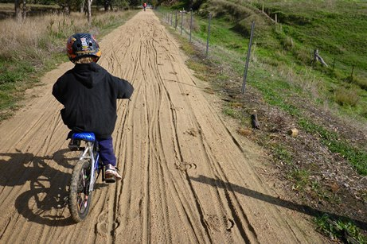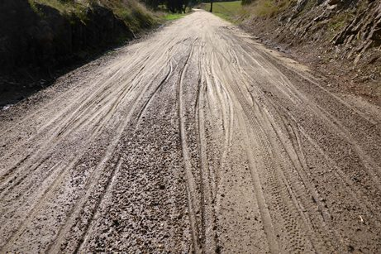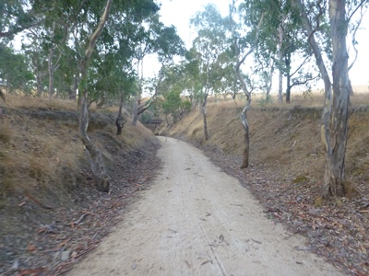

**Wet Conditions – Soft surface, in sections it can be very challenging to ride**

**Dry Conditions – Good solid surface**

* Training is an essential component for all participants to prepare themselves for any bike ride. However for the Cheviot Ride it is highly recommended you include:-
* Training on softer surfaces to prepare all participants for riding the Great Victorian Rail Trail in wet conditions where wheels will sink into the surface
* Grass sports ovals are highly recommended
* Regularly training on a grass sports oval for an extended period of time will help build endurance within all participants & help them all cope with the challenge of a wet gravel Rail Trail

**Rail Trail Hazards & Why you MUST KEEP your Group TOGETHER**

* It is essential to keep your group together to prepare & warn all riders of potential hazards along the rail trail

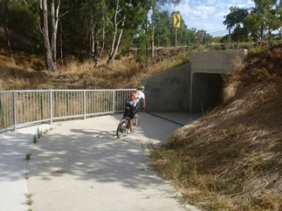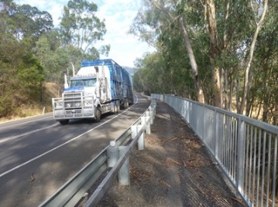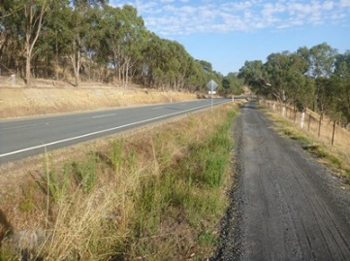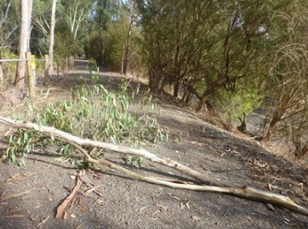

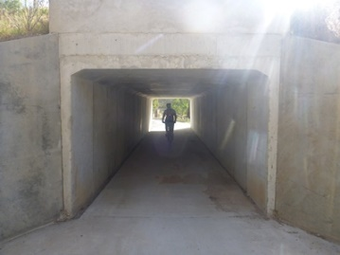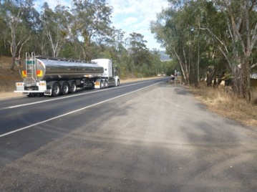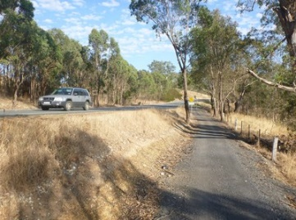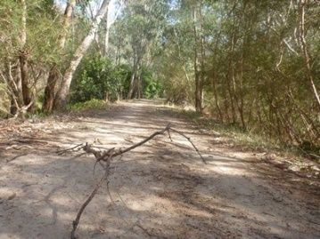

# CHEVIOT TUNNEL

* The Cheviot Tunnel is a highlight of the entire Great Victorian Rail Trail
* 201m long
* 4.7m high
* 283m above sea level
* Due to the darkness in the Centre of the Tunnel it is also potentially one of our major hazards throughout the duration of the ride
* What safety precautions will be implemented specifically relating to the Cheviot Tunnel:-
* **ALL SCHOOLS SHOULD HAVE A FRONT & REAR LIGHT MOUNTED ON EACH BIKE**
* **While riding through the Cheviot Tunnel under NO CIRCUMSTANCES is any rider permitted to use the Flash OR Strobe function on either their front or rear light**
* Glow Sticks will be provided by Blackwood SSOEC
* Flood Lights will be provided by Blackwood SSOEC
* While everyone is riding from Molesworth to the Cheviot Tunnel Blackwood OSS volunteers will be at the Cheviot Tunnel placing:-
* A row of glow sticks on either of the tunnel 1m in from the wall to create a safe riding path
* 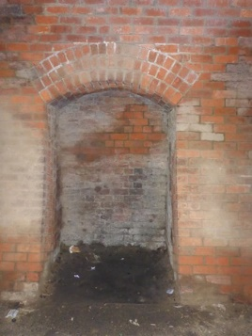1 flood light in each of the three safety alcoves in the tunnel

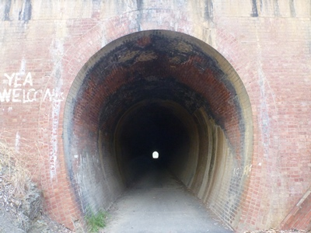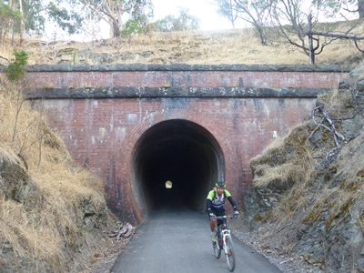

**Tunnel Safety Alcove**

**Cheviot Tunnel Riding Options**

* Glow Sticks Only – NO BIKE LIGHTS
* Glow Sticks & Bike Lights
* Glow Sticks, Bike Lights & Floodlights

**It is our intention to spend some time at the tunnel to allow everyone the opportunity to enjoy, experience & have fun riding through the Cheviot Tunnel**

**THEREFORE ALL STAFF ARE RESPONSIBLE FOR THE FULL SUPERVISION OF THEIR STUDENTS DURING OUR TIME AT THE CHEVIOT TUNNEL**

# EMERGENCY NUMBERS

|  |  |  |  |  |  |
| --- | --- | --- | --- | --- | --- |
|  | **AMBULANCE** | **POLICE** | **FIRE** | **HOSPITAL** | **SHIRE** |
| **Mansfield** | 000 | 5775-2555 | 000 | 5775-8800 | 5775-8555 |
| **Alexandra** | 000 | 5772-1040 | 000 | 5772-0900 | 5772-0333  1800 633-792 |
| **Yea** | 000 | 5797-2630 | 000 | 5736-0400 |
| **Seymour** | 000 | 5735-0200 | 000 | 5793-6100 | 5734-6200 |

# SAG WAGON

* As well as the Blackwood Vehicle there will be a Sag Wagon following the entire group throughout each riding day.

**EVERY STUDENT THAT RIDES ON A SAG WAGON MUST BE ACCOMPANIED BY A STAFF MEMBER / ADULT FROM THEIR SCHOOL.**

**IT IS THE FULL RESPONSIBILITY OF PRINCIPALS TO ENDORSE STAFF SUPPORT OFFICERS (SSO’s) & PARENTS/VOLUNTEERS FROM YOUR SCHOOL ASSISTING WITH YOUR SCHOOLS CHEVIOT RIDE GROUP, AS ELIGIBLE TO TRAVEL ON SAG WAGONS or CONTINUE RIDING WITH THE GROUP WITHOUT DIRECT TEACHER SUPERVISION PRIOR TO DEPARTING FOR THE CHEVIOT RIDE.**

* **The school identified as the designated ‘Sag Wagon’ support will have their vehicle refuelled at the expense of the Blackwood Special Schools for the duration of the Cheviot Ride.**
* *Your School Principal & Parents need to be aware of and give consent and approval for the following:-*
  + - **Both Students and Staff from your school MAY BE required to travel in another schools bus for safety reason:-**
      * ie accident / injury;
      * bicycle malfunction;
      * tiredness; or
      * group transportation needs.
* Any bus selected as a ‘Sag Wagon’ will be an Accredited Special School Bus only.
* Drivers of these buses will be licenced and experienced in driving that particular bus.
* **IF YOUR BUS IS SELECTED AS A SAG WAGON BUS IT MAY BE REQUIRED TO TOW A TRAILER FROM ANOTHER SPECIAL SCHOOL.**
* Communication between **ALL** school groups and **ALL** ‘Sag Wagons’ will be available through the use of Walkie Talkies.
* If a decision is made to split the group into smaller riding clusters, each cluster will be supported by their own ‘Sag Wagon’ supplied from an individual school within that cluster.
* **DRIVERS OF THE ‘SAG WAGONS’ WILL BE PROVIDED WITH APPROPRIATE ROAD MAPS AND INSTRUCTIONS.**

# MORE INFORMATION

A very comprehensive **WEBSITE** of the trail has been produced which includes:-

* Maps;
* Photos;
* Route Details;

and is a *MUST SEE* before you arrive.

[**http://www.greatvictorianrailtrail.com.au/**](http://www.greatvictorianrailtrail.com.au/)

You will also find a link to this website on Blackwood SSOEC Website:-

[**www.blackwoodssoec.vic.edu.au**](http://www.blackwoodssoec.vic.edu.au)