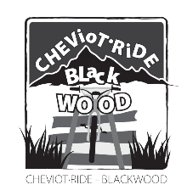
CHEVIOT RIDE
DIETARY REQUIREMENTS FORM

- This Form is designed as a direct to help the Rubicon Catering Staff;
- If any of your students or staff have dietary needs, this Form MUST be returned to Blackwood Staff by Friday 11th NOVEMBER 2022 – please feel free to photocopy form if required;
- IF THE FORM IS NOT RETURNED BY FRIDAY 11th NOVEMBER 2022 – IT WILL BE ASSUMED THAT THERE IS NO SPECIAL DIETARY REQUIREMENTS WITHIN YOUR GROUP.

SCHOOL NAME:- _____________________________________________

STUDENT NAME Vegetarian Other Notes

____________________________ ___________________
___________________
____________________________ ___________________
___________________
____________________________ ___________________
___________________
____________________________ ___________________
___________________
____________________________ ___________________
___________________
____________________________ ___________________
___________________

STAFF NAME Vegetarian Other Notes

____________________________ ___________________
___________________
____________________________ ___________________
___________________
____________________________ ___________________
___________________

