


Inclusion

Tolerance

Appreciation

Challenge

Respect

Teamwork

THE TENT SHELTER ACCOMMODATION SITE
RISK MANAGEMENT PLAN
Risk Register:

School:

Supervising teachers/staff:

Program/Excursion:

Year Level:

Dates:

Location(s):

Note to Teachers, Principals & School Councils: Blackwood Staff are employed to create, maintain, implement, supervise and instruct activities that groups participate in at Blackwood Special Schools Outdoor Education Centre. During the implementation of activities Blackwood Staff may request support from School Staff to help run & Co-ordinate some activities – if this occurs School Staff will be instructed on guidelines & safe implementation of each activity. While Blackwood Staff have expertise in all activities conducted at Blackwood, School Staff are fully responsible for their students at ALL TIMES & Blackwood Staff cannot be considered part of the staff : student ratio at any stage during your visit to Blackwood Special Schools Outdoor Education Centre. Please also be aware that due to unforseen circumstances programs may be modified. So while Activities that have not been approved by School Councils & Principals will not be conducted – some activities may be implemented at different times or on different days during your School’s visit to Blackwood Special Schools Outdoor Education Centre. Thank you.

The Tent Shelter Accommodates: 22 People

Tents | People
8 X 2 Person Safari Tents | 16
2 X 3 Person Safari Tents | 6

GROUP VEHICLE PARKING

- It is highly recommended by the Blackwood Special Schools Outdoor Education Centre Inc. Committee that all vehicles upon arrival (and return from all Activity Sessions) disconnect trailers and park Vehicles & Trailers in safe & appropriate locations.

- AT ALL TIMES ALL VEHICLES should be positioned ready to depart from the Centre in the event of an Emergency within the group – or a requirement of Centre Evacuation.

Map References: Topographical VicMaps (All Grid References given are off the Trentham Map)

Map: Trentham
Map No.: 7723 – 2 – 3
Scale: 1:25,000
Edition: 1st Edition 1994
 |  | Blackwood
Melways Reference – Edition 29 (2002) |  | Map 609 E 11
VicRoads Map Reference – Edition 4 | State Map | Map 59 F 9
 | Town Map | Map 290 G 4
Topographical Grid Reference |  | GR 6149

Accommodation Site Details:

 |  |  |  |  | VicRoads Map – Edition 7
 | ACCOMMODATION SITE | ADDRESS | PHONE No. | Melways Ref  Edition 35 (2008) | State Map  Reference | Town Map  Reference | Topographic  Grid Ref
 | BSSOEC Tent Shelter | Corner of Cann & McLennan Streets, Blackwood, 3458 | 5368-6383 | Map 909 E 11 | Map 59 F 9 | Map 585 R 3 | GR 615485
The Committee have assessed the roads, facilities, surrounds and buildings that are utilised while Schools are staying at Blackwood Special Schools Outdoor Education Centre Inc. and have developed the following Plan.

A qualitative measure of consequence or impact has been utilised as follows.
DESCRIPTOR | DETAILS
insignificant | No injuries, low financial loss. Inconsequential or no damage  Little or no disruption to public/infrastructure
minor | First aid treatment on site Some damage  Some disruption to public Some financial loss
moderate | Medical treatment required Some hospitalisation  Insufficient resources (human/material)  Moderate damage Moderate disruption to public High financial loss
major | Extensive injuries Significant hospitalisation Fatalities  Extensive support/emergency personnel required  Significant damage Significant disruption to public Major financial loss
A qualitative measure of the likelihood of the occurrence happening is:-
DESCRIPTOR | DETAILS
Almost certain | The event is expected to occur in most circumstances
Likely | The event will probably occur in most circumstances
Unlikely | The event could occur at some time
Rare | The event will only occur in exceptional circumstances.

A qualitative measure of risk will be High Risk – Moderate risk and Low risk.
Based on the likelihood and consequence analysis.

CONSEQUENCES
LIKELIHOOD | Insignificant | Minor | Moderate | Major
Almost certain | M | M | H | H
Likely | M | M | M | H
Unlikely | L | L | L | M
Rare | L | L | L | M

REMEMBER: That while this Risk Management Plan identifies Risks in relation to student participation they
also apply to staff in all ‘Identified Risk Categories’
Identified Risk Category | Risk Description | Existing Controls | Rating |  |  | Treatment Priority | Action Plan Mitigation Strategy | Responsible Person | Treatment
What is the risk area, activity, event, situation or parameters? | Describe the risk event, cause/s and consequence/s | Describe any existing policy, procedure, practice or device that acts to minimise a particular risk | Effectiveness of existing controls | Risk Consequences | Risk Likelihood | If control effectiveness is poor or unknown provide further treatment | Plan to be implemented to minimise risk | Who is responsible to minimise & manage risk if situation arises? | For those risks requiring treatment in addition to the existing controls. List:  - What will be done?  - When will it happen?
Car Park | Vehicle accident in the Car Park | a) Staff to drive safely at all times  b) Staff to be aware of students within the car park  c) Staff with students in the car park are to be aware of moving vehicles & ensure students are safe at all times  d) Staff reversing a vehicle at any time MUST have a 2nd staff member outside & at the rear of the vehicle / trailer to ensure it is safe for the vehicle to move backwards | Satisfactory  Poor  Unknown | Major  Moderate  Minor  Insignificant | Almost certain  Likely  Unlikely  Rare | High  Medium  Low | Students to be fully supervised by individual staff at all times  Staff to be fully aware of the potential dangers of reversing a vehicle in a student environment and to ensure the back of the vehicle is clear any time they need to reverse | Staff from individual schools at all times  Blackwood Staff to inform staff of safety regulations and ensure they are adhered to | Talk to staff about supervision & safety regulations implemented for all Blackwood Special Schools Outdoor Education Centre activities – 1st Aid & ambulance if required  Notify emergency services, BSSOEC Committee President & DEECD
Kitchen | Slipping on a wet floor | Any spillage on the kitchen floor is to be immediately mop up under the supervision of staff | Satisfactory  Poor  Unknown | Major  Moderate  Minor  Insignificant | Almost certain  Likely  Unlikely  Rare | High  Medium  Low | Students to be fully supervised by individual staff at all times | Staff from individual schools at all times | 1st Aid  Notify Emergency Services  Notify BSSOEC Staff  Notify Individual School  Incident Report Form  Notify DEECD
Kitchen | Cuts from a knife or other sharp objects | - Knives to be stored in the knife block when not in use  - Students to be fully supervised when using knives  - Knives NOT to be left unattended by staff on any bench | Satisfactory  Poor  Unknown | Major  Moderate  Minor  Insignificant | Almost certain  Likely  Unlikely  Rare | High  Medium  Low | Students to be fully supervised by individual staff at all times | Staff from individual schools at all times | 1st Aid  Notify Emergency Services  Notify BSSOEC Staff  Notify Individual School  Incident Report Form  Notify DEECD
Kitchen | Burns while cooking is being performed in the Kitchen | - Students to be fully supervised when assisting with preparing meals  - A clear the area prior to hot pots & pans being moved in the kitchen | Satisfactory  Poor  Unknown | Major  Moderate  Minor  Insignificant | Almost certain  Likely  Unlikely  Rare | High  Medium  Low | Students to be fully supervised by individual staff at all times | Staff from individual schools at all times | 1st Aid  Notify Emergency Services  Notify BSSOEC Staff  Notify Individual School  Incident Report Form  Notify DEECD
Kitchen | Scalding from the Urn | - Urn to be kept at a low temperature at all times  - Students to be fully supervised at all times when access the urn | Satisfactory  Poor  Unknown | Major  Moderate  Minor  Insignificant | Almost certain  Likely  Unlikely  Rare | High  Medium  Low | Students to be fully supervised by individual staff at all times | Staff from individual schools at all times | 1st Aid  Notify Emergency Services  Notify BSSOEC Staff  Notify Individual School  Incident Report Form  Notify DEECD
Kitchen | Scalding & Accidents while doing the dishes | - Staff to supervise the preparation of hot water for the dishes  - Dishes to be stacked safely on the sink  - Once dried immediately put away | Satisfactory  Poor  Unknown | Major  Moderate  Minor  Insignificant | Almost certain  Likely  Unlikely  Rare | High  Medium  Low | Students to be fully supervised by individual staff at all times | Staff from individual schools at all times | 1st Aid  Notify Emergency Services  Notify BSSOEC Staff  Notify Individual School  Incident Report Form  Notify DEECD
Eating Area | Slipping on a wet floor | Any spillage on the kitchen floor is to be immediately mopped up under the supervision of staff | Satisfactory  Poor  Unknown | Major  Moderate  Minor  Insignificant | Almost certain  Likely  Unlikely  Rare | High  Medium  Low | Students to be fully supervised by individual staff at all times | Staff from individual schools at all times | 1st Aid  Notify Emergency Services  Notify BSSOEC Staff  Notify Individual School  Incident Report Form  Notify DEECD
Eating Area | Tripping over furniture, bags & objects obstructing walkways | When not in use all furniture, bags & objects are to be safely stored away in appropriate storage locations | Satisfactory  Poor  Unknown | Major  Moderate  Minor  Insignificant | Almost certain  Likely  Unlikely  Rare | High  Medium  Low | Students to be fully supervised by individual staff at all times | Staff from individual schools at all times | 1st Aid  Notify Emergency Services  Notify BSSOEC Staff  Notify Individual School  Incident Report Form  Notify DEECD
Eating Area | Falling off the bench seats as a result of:-  - Sitting down on the end of the bench seat  OR  - Someone standing up from the bench seat while someone else is sitting on the end of the same bench seat | Advice students NOT to sit on the end of the bench seats at anytime  &  To be aware of other people sitting on the same bench seat and to stand up slowly when moving off the bench seat | Satisfactory  Poor  Unknown | Major  Moderate  Minor  Insignificant | Almost certain  Likely  Unlikely  Rare | High  Medium  Low | Students to be fully supervised by individual staff at all times | Staff from individual schools at all times | 1st Aid  Notify Emergency Services  Notify BSSOEC Staff  Notify Individual School  Incident Report Form  Notify DEECD
Indoor Games Area  (same as Eating Area) | Falling over while participating in activities in the Lounge Room | THERE IS NO RUNNING IN THE BUILDING  There are NO running activities to be undertaken in the building  Unused or unrequired activity equipment & furniture to be safely & appropriately stored during activity time | Satisfactory  Poor  Unknown | Major  Moderate  Minor  Insignificant | Almost certain  Likely  Unlikely  Rare | High  Medium  Low | Students to be fully supervised by individual staff at all times | Staff from individual schools at all times | 1st Aid  Notify Emergency Services  Notify BSSOEC Staff  Notify Individual School  Incident Report Form  Notify DEECD
Electrical Cords & Power Boards | Tripping over Electrical Cords and / or Power Boards that are being throughout the Building | THERE IS NO RUNNING IN THE BUILDING  Electrical Cords & Power Cords must be used in their correct manner  Electrical Cords MUST BE covered or clearly marked to ensure tripping does not become a hazard | Satisfactory  Poor  Unknown | Major  Moderate  Minor  Insignificant | Almost certain  Likely  Unlikely  Rare | High  Medium  Low | Students to be fully supervised by individual staff at all times | Staff from individual schools at all times | 1st Aid  Notify Emergency Services  Notify BSSOEC Staff  Notify Individual School  Incident Report Form  Notify DEECD
Indoor Open Fire | Fires | NO STUDENT IS TO ACCESS ANY FIREPLACE ONCE THE FIRE IS LIT  STUDENTS ARE NOT PERMITTED TO PLACE WOOD ON THE FIRES AT ANY TIME | Satisfactory  Poor  Unknown | Major  Moderate  Minor  Insignificant | Almost certain  Likely  Unlikely  Rare | High  Medium  Low | Students to be fully supervised by individual staff at all times | Staff from individual schools at all times | 1st Aid  Notify Emergency Services  Notify BSSOEC Staff  Notify Individual School  Incident Report Form  Notify DEECD
Indoor Open Fire | Wood Boxes | Students to access the Wood Boxes only under direct staff supervision  Ensure no-one lifts anything too heavy when filling up the inside & outside wood boxes | Satisfactory  Poor  Unknown | Major  Moderate  Minor  Insignificant | Almost certain  Likely  Unlikely  Rare | High  Medium  Low | Students to be fully supervised by individual staff at all times | Staff from individual schools at all times | 1st Aid  Notify Emergency Services  Notify BSSOEC Staff  Notify Individual School  Incident Report Form  Notify DEECD
Indoor Open Fire | Cooking | All Cooking is performed on open fires  EXCEPT DURING DAYS of TOTAL FIRE BAN & DAYS of EXTREME FIRE DANGER  (a Microwave & Electric Hot Plates at provided for these days) | Satisfactory  Poor  Unknown | Major  Moderate  Minor  Insignificant | Almost certain  Likely  Unlikely  Rare | High  Medium  Low | Students to be fully supervised by individual staff at all times | Staff from individual schools at all times | 1st Aid  Notify Emergency Services  Notify BSSOEC Staff  Notify Individual School  Incident Report Form  Notify DEECD
Indoor Open Fire | Someone getting burnt while cooking at the Tent Shelter | Cooking is only to be performed under the very strict supervision of staff AT ALL TIMES | Satisfactory  Poor  Unknown | Major  Moderate  Minor  Insignificant | Almost certain  Likely  Unlikely  Rare | High  Medium  Low | Students to be fully supervised by individual staff at all times | Staff from individual schools at all times | 1st Aid  Notify Emergency Services  Notify BSSOEC Staff  Notify Individual School  Incident Report Form  Notify DEECD
Indoor Open Fire | Someone is injured by the fire while moving around or using the Tent Shelter as a recreation area | Students are to be fully supervised by staff AT ALL TIMES while accessing the Tent Shelter | Satisfactory  Poor  Unknown | Major  Moderate  Minor  Insignificant | Almost certain  Likely  Unlikely  Rare | High  Medium  Low | Students to be fully supervised by individual staff at all times | Staff from individual schools at all times | 1st Aid  Notify Emergency Services  Notify BSSOEC Staff  Notify Individual School  Incident Report Form  Notify DEECD
Tents | Tripping over clothing, luggage, bedding & other personal belongings inside the Tent | Storage of Luggage & Gear to be located in safe & appropriate locations  Daily inspections to ensure the tidiness of tents | Satisfactory  Poor  Unknown | Major  Moderate  Minor  Insignificant | Almost certain  Likely  Unlikely  Rare | High  Medium  Low | Students to be fully supervised by individual staff at all times | Staff from individual schools at all times | 1st Aid  Notify Emergency Services  Notify BSSOEC Staff  Notify Individual School  Incident Report Form  Notify DEECD
Tents | Tripping over around the Tent Site Areas | NO RUNNING OR ACTIVE MOVEMENT IN THE BEDROOMS AT ANY TIME  Students & Staff to have access to individual torches for movement at night | Satisfactory  Poor  Unknown | Major  Moderate  Minor  Insignificant | Almost certain  Likely  Unlikely  Rare | High  Medium  Low | Students to be fully supervised by individual staff at all times | Staff from individual schools at all times | 1st Aid  Notify Emergency Services  Notify BSSOEC Staff  Notify Individual School  Incident Report Form  Notify DEECD
Bathrooms, Toilets & Laundry | Slipping on a wet floor | After any shower or spillage on any bathroom, toilet or laundry floor it is to be immediately mopped up under the supervision of staff | Satisfactory  Poor  Unknown | Major  Moderate  Minor  Insignificant | Almost certain  Likely  Unlikely  Rare | High  Medium  Low | Students to be fully supervised by individual staff at all times | Staff from individual schools at all times | 1st Aid  Notify Emergency Services  Notify BSSOEC Staff  Notify Individual School  Incident Report Form  Notify DEECD
Bathrooms, Toilets & Laundry | Tripping over clothing, towels, furniture, bags & objects obstructing walkways | When not in use all clothing, towels, furniture, bags & objects are to be safely stored away in appropriate storage locations | Satisfactory  Poor  Unknown | Major  Moderate  Minor  Insignificant | Almost certain  Likely  Unlikely  Rare | High  Medium  Low | Students to be fully supervised by individual staff at all times | Staff from individual schools at all times | 1st Aid  Notify Emergency Services  Notify BSSOEC Staff  Notify Individual School  Incident Report Form  Notify DEECD
Bathrooms, Toilets & Laundry | Scalding & Accidents | Staff to supervise the preparation of hot water  Staff to supervise showering sessions at all times | Satisfactory  Poor  Unknown | Major  Moderate  Minor  Insignificant | Almost certain  Likely  Unlikely  Rare | High  Medium  Low | Students to be fully supervised by individual staff at all times | Staff from individual schools at all times | 1st Aid  Notify Emergency Services  Notify BSSOEC Staff  Notify Individual School  Incident Report Form  Notify DEECD
Bathrooms | Sexual Harassment | MORE THAN ONE (1) STAFF MEMBER TO SUPERVISE SHOWERING SESSIONS AT ALL TIMES  NO MALE STAFF TO SUPERVISE FEMALE STUDENT SHOWER or TOILET SESSIONS AT ANY TIME  STAFF TO SET APPROPRIATE SHOWERING SCHEDULES FOR FEMALE & MALE STUDENTS | Satisfactory  Poor  Unknown | Major  Moderate  Minor  Insignificant | Almost certain  Likely  Unlikely  Rare | High  Medium  Low | Students to be fully supervised by individual staff at all times | Staff from individual schools at all times | 1st Aid  Notify Emergency Services  Notify BSSOEC Staff  Notify Individual School  Incident Report Form  Notify DEECD
Games Inside & Outside the Building | Fighting over the Games Equipment | Staff to fully supervise students during activity & free time | Satisfactory  Poor  Unknown | Major  Moderate  Minor  Insignificant | Almost certain  Likely  Unlikely  Rare | High  Medium  Low | Students to be fully supervised by individual staff at all times | Staff from individual schools at all times | 1st Aid  Notify Emergency Services  Notify BSSOEC Staff  Notify Individual School  Incident Report Form
Games Inside & Outside the Building | Students throwing Games Equipment at each other | Staff to fully supervise students during activity & free time | Satisfactory  Poor  Unknown | Major  Moderate  Minor  Insignificant | Almost certain  Likely  Unlikely  Rare | High  Medium  Low | Students to be fully supervised by individual staff at all times | Staff from individual schools at all times | 1st Aid  Notify Emergency Services  Notify BSSOEC Staff  Notify Individual School  Incident Report Form
Games Inside & Outside the Building | Students misusing & damaging Games Equipment | Staff to fully supervise students during activity & free time | Satisfactory  Poor  Unknown | Major  Moderate  Minor  Insignificant | Almost certain  Likely  Unlikely  Rare | High  Medium  Low | Students to be fully supervised by individual staff at all times | Staff from individual schools at all times | 1st Aid  Notify Emergency Services  Notify BSSOEC Staff  Notify Individual School  Incident Report Form
Games Inside & Outside the Building | Balls or sporting equipment rolling, bouncing or flying beyond the boundary fence | Staff to fully supervise students during activity & free time  Staff to retrieve any balls or sporting equipment from beyond the boundary fence | Satisfactory  Poor  Unknown | Major  Moderate  Minor  Insignificant | Almost certain  Likely  Unlikely  Rare | High  Medium  Low | Students to be fully supervised by individual staff at all times | Staff from individual schools at all times | 1st Aid  Notify Emergency Services  Notify BSSOEC Staff  Notify Individual School  Incident Report Form  Notify Department of Education
Yabby Dam | Students entering the Yabby Dam Activity Area without staff supervision | Staff to fully supervise students AT ALL TIMES  YABBY DAM TO BE LOCKED AT ALL TIMES WHEN NOT IN USE | Satisfactory  Poor  Unknown | Major  Moderate  Minor  Insignificant | Almost certain  Likely  Unlikely  Rare | High  Medium  Low | Students to be fully supervised by individual staff at all times | Staff from individual schools at all times | 1st Aid  Notify Emergency Services  Notify BSSOEC Staff  Notify Individual School  Incident Report Form  Notify Department of Education
Lost Student | While staying at the Accommodation Site a student becomes lost from the Accommodation Site Environment | Staff to fully supervise students AT ALL TIMES | Satisfactory  Poor  Unknown | Major  Moderate  Minor  Insignificant | Almost certain  Likely  Unlikely  Rare | High  Medium  Low | Students to be fully supervised by individual staff at all times | Staff from individual schools at all times | All activities will be stopped immediately  Students brought together inside the accommodation site  Appropriate treatment will be implemented  Search Initiated  If required school, parents, DEECD, Emerg Services & President notified
Timber Hazards  ie Seats, Tent Pads, Steps, Benches | Someone trips over a timber hazard while moving around the Tent Shelter Area | Highlight the importance of moving safely & slowly around the Tent Shelter Area.  Full Staff supervision AT ALL TIMES | Satisfactory  Poor  Unknown | Major  Moderate  Minor  Insignificant | Almost certain  Likely  Unlikely  Rare | High  Medium  Low | Students to be fully supervised by individual staff at all times | Staff from individual schools at all times | 1st Aid  Notify Emergency Services  Notify BSSOEC Staff  Notify Individual School  Incident Report Form  Notify DEECD
Campfire | Students are excited about participating in the activity and runs within the Campfire Activity Area | During the introduction of the activity it is clearly explained to the students that under no circumstances are they to run during the activity | Satisfactory  Poor  Unknown | Major  Moderate  Minor  Insignificant | Almost certain  Likely  Unlikely  Rare | High  Medium  Low | Students to be fully supervised by individual staff at all times | Staff from individual schools at all times | 1st Aid  Notify Emergency Services  Notify BSSOEC Staff  Notify Individual School  Incident Report Form  Notify DEECD
Campfire | During the excitement of the activity a student moves about without full consideration for the surrounding & unfamiliar environment | Students are reminded that they are to move about the surrounding area in a safe and controlled manner at all times  They are to be aware of the environment at all times | Satisfactory  Poor  Unknown | Major  Moderate  Minor  Insignificant | Almost certain  Likely  Unlikely  Rare | High  Medium  Low | Students to be fully supervised by individual staff at all times | Staff from individual schools at all times | 1st Aid  Notify Emergency Services  Notify BSSOEC Staff  Notify Individual School  Incident Report Form  Notify DEECD
Campfire | A student is injured while collecting fire wood | Students are informed to walk at all times  Students are advised to carry only small amounts of fire wood  Students DO NOT throw or swing any fire wood | Satisfactory  Poor  Unknown | Major  Moderate  Minor  Insignificant | Almost certain  Likely  Unlikely  Rare | High  Medium  Low | Students to be fully supervised by individual staff at all times | Staff from individual schools at all times | 1st Aid  Notify Emergency Services  Notify BSSOEC Staff  Notify Individual School  Incident Report Form  Notify DEECD
Campfire | A student or staff member is burnt during the lighting of the Fire or the implementation of the Activity | Supervision  If equipment falls into the fire pit it is to be retrieved by Staff only  Students only place extra fire wood on the fire under Staff Supervision | Satisfactory  Poor  Unknown | Major  Moderate  Minor  Insignificant | Almost certain  Likely  Unlikely  Rare | High  Medium  Low | Students to be fully supervised by individual staff at all times | Staff from individual schools at all times | 1st Aid  Notify Emergency Services  Notify BSSOEC Staff  Notify Individual School  Incident Report Form  Notify DEECD
Campfire | A student or staff member is accidentally burnt as a direct result of their movement around the Fire | Once the Fire is lit no-one is allowed to move across | Satisfactory  Poor  Unknown | Major  Moderate  Minor  Insignificant | Almost certain  Likely  Unlikely  Rare | High  Medium  Low | Students to be fully supervised by individual staff at all times | Staff from individual schools at all times | 1st Aid  Notify Emergency Services  Notify BSSOEC Staff  Notify Individual School  Incident Report Form  Notify DEECD
Campfire | A student is injured in the excitement of watching the fire be lit – or while lighting the fire | If it is not a requirement of the program Staff will light the fire  All students must be sitting or at a safe distance from the fire pit when the fire is being lit.  STUDENTS LIGHTING the FIRE  Students will be taught how to correctly strike a match  Students MUST demonstrate how to strike a match  Strictly only one student Lighting the fire at any one time – other students MUST BE seated or at a safe distance from the fire pit | Satisfactory  Poor  Unknown | Major  Moderate  Minor  Insignificant | Almost certain  Likely  Unlikely  Rare | High  Medium  Low | Students to be fully supervised by individual staff at all times | Staff from individual schools at all times | 1st Aid  Notify Emergency Services  Notify BSSOEC Staff  Notify Individual School  Incident Report Form  Notify DEECD
Campfire | A person is injured or covered in smoke & ash during the extinguishing of the Fire | The Fire is Extinguished under FULL staff supervision  All people not extinguishing the fire are removed from the  immediate area  Water is poured on the fire until the area can be touched by a bare hand | Satisfactory  Poor  Unknown | Major  Moderate  Minor  Insignificant | Almost certain  Likely  Unlikely  Rare | High  Medium  Low | Students to be fully supervised by individual staff at all times | Staff from individual schools at all times | 1st Aid  Notify Emergency Services  Notify BSSOEC Staff  Notify Individual School  Incident Report Form  Notify DEECD

Risk Treatment Priority Table
Use the table below to decide the overall risk rating and represent the priority of the each risk for treatment.

Consequences | Major | Lost Student  Sexual Harassment  Yabby Dam | Car Park | Playground
Consequences | Moderate | Electrical Cords & Power Boards | Indoor Games Area  Bathrooms, Toilets & Laundry  Tents  Indoor Open Fire  Campfire | Eating Area  Kitchen  Timber Hazards
Consequences | Minor |  | Games Inside & Outside the Building
Consequences | Insignificant
 |  | Rare | Unlikely | Likely | Almost certain
 |  | Likelihood

Treat | Monitor

TENT SHELTER ACCOMMODATION SITE FLOOR PLAN TENT SHELTER PROPERTY MAP
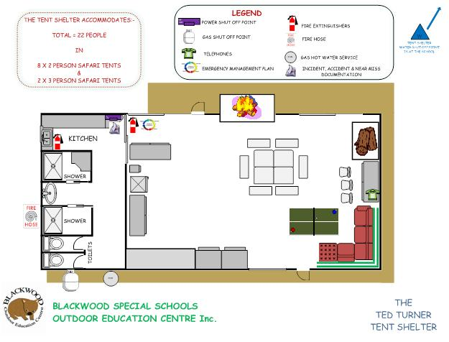
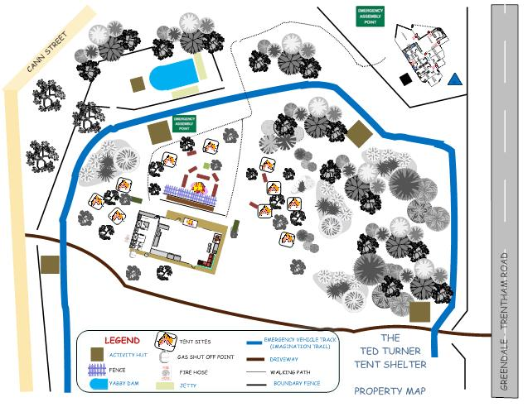

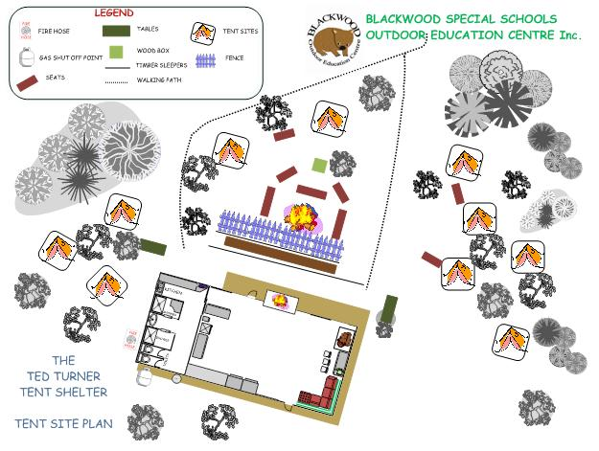

TENT SHELTER TENT SITE PLAN

Use the Risk Treatment Priority Table at the end of this document to determine the treatment priority.

